**Bash Execution**

1. Application launch
2. Execute startserver.sh 🡪 Pass



1. Check the Task manager for the Application 🡪 Pass

1. Open cmd (Command Prompt) > verify for PORT environment variable display 🡪 Pass

NOTE: Environment Variables has the PORT variable as 8088 configured.

1. Open a new terminal > Run the POST to / hash request call >
   1. Execute postrequest.sh > Received a job identifier 🡪Pass
   2. Displayed sha512 hash password 🡪 Not applicable.
   3. SHA512 Validation 🡪 Not Applicable because I don’t see it in the bash output.

NOTE: Need to discuss with Product Owner and Business for clarification (2.b and 2.c)

1. Run the POST to / hash request call > Password data validation > manually executing post to /hash calls
   1. Only Alphabets 🡪 Pass

* 1. Only Numeric 🡪 Pass

* 1. Only Special Characters 🡪 Pass

* 1. Alphabets and Numeric 🡪 Pass

* 1. Alphabets and Special Characters 🡪 Pass

* 1. Alphabets, numeric and special characters 🡪 Pass

* 1. Numeric and special characters 🡪 Pass

* 1. Password with double quotes in the password value 🡪 Fail

1. Run the POST to /hash request call > Password length validation 🡪 accepting more characters 🡪 To verify

NOTE: Need to discuss with Product Owner and Business for password requirements

1. Run the POST to / hash request call with Empty Password (only with double quotes) 🡪 To Verify

NOTE: It should technically Fail, but it returns a job identifier which is wrong

Need to discuss with Product Owner and Business for password requirements

1. Run the GET to /hash request call >
   1. Execute getrequest.sh for an existing job identifier > returns base64 encoded password with an **existing** job identifier 🡪 Pass

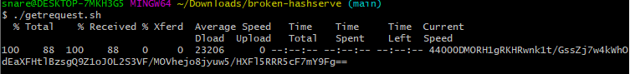

* 1. Manually executed the get to /hash call with valid (1 or 001) job identifier 🡪 Pass

* 1. Validation > manually executed the get to /hash call with an Invalid job identifier as 125 > it should throw an error 🡪 Pass

1. Run the GET to / stats request call > Execute getstat.sh request > Validation < count match for ‘Total Hash Requests’ 🡪 To verify

NOTE:

Need to discuss with Product Owner and Business for ‘Total Hash Requests’

GET stats API call response shows only the POST to /hash ‘TotalRequests’ response count and not the Hash GET to /hash ‘TotalRequests’ response counts.

* 1. **Post to /hash** request call
     1. Count the total number of responseJob identifiers > count is 11 🡪 To Verify because it includes the successful and Malformed Post request

* + 1. Execute getstat.sh request > count of Total Post Requests matched 11 🡪 Pass

* 1. **GET to /hash** request call
     1. Count the total number of Get to /hash calls hit > count is 4 🡪 To Verify as it does not include any GET hash request.

* + 1. Execute getstat.sh request > count of Total Get Requests 🡪 Fail

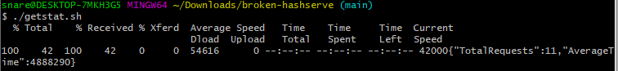

1. Process multiple connections simultaneously 🡪 Job Identifier changes simultaneously on First and Second terminals 🡪 Pass
   1. First Terminal run

* 1. Second Terminal runs

Note: Job Identifier simultaneously change are displayed.

Example:

|  |  |
| --- | --- |
| Job Identifier | Terminal |
| 22 | First |
| 23 | Second |
| 24 | First |
| 25 | Second |
| 26 | First |
| 27 | Second |

1. Process graceful shutdown 🡪 Fail (no 200 response)
   1. Start the server in the First terminal > execute startserver.sh



* 1. Start multiplebash.sh to run multiple Post request in Second Terminal

* 1. Run shutdown.sh from Third Terminal

* 1. Check Second terminal for graceful shutdown

* 1. Check the First terminal for shutdown

1. Start the application and stop the application > without executing any Post / Get calls🡪Fail (No 200 response)
   1. Execute starteserver.sh in First terminal



* 1. Execute shutdown.sh in Second Terminal

* 1. Check First terminal for shutdown

1. Application Shutdown without starting the Application > Pass
   1. Open Terminal and make sure Application is already shut down

* 1. Execute shutdown.sh

